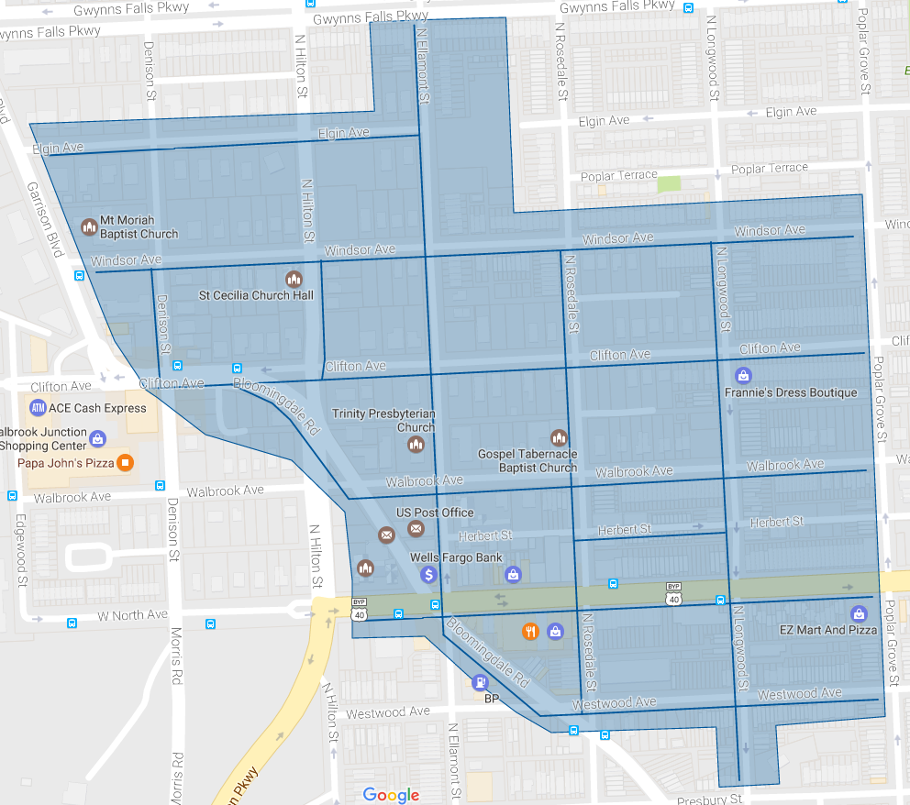

Figure 1: Walbrook Ph 1 Operation Pipeline job shown shaded in blue with the streets to be worked highlighted.