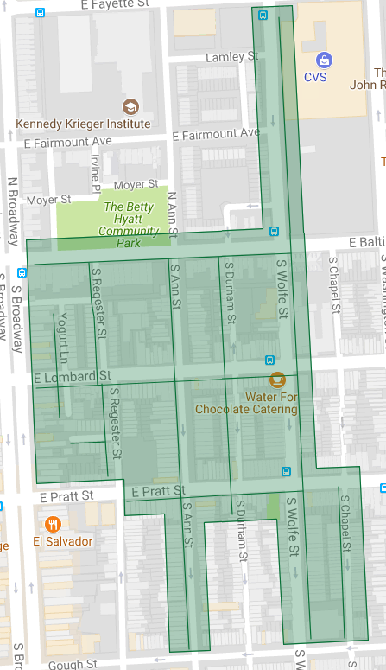

Figure 1: Upper Fells Point Phase 1 Operation Pipeline job shown shaded in green with the streets to be worked highlighted.