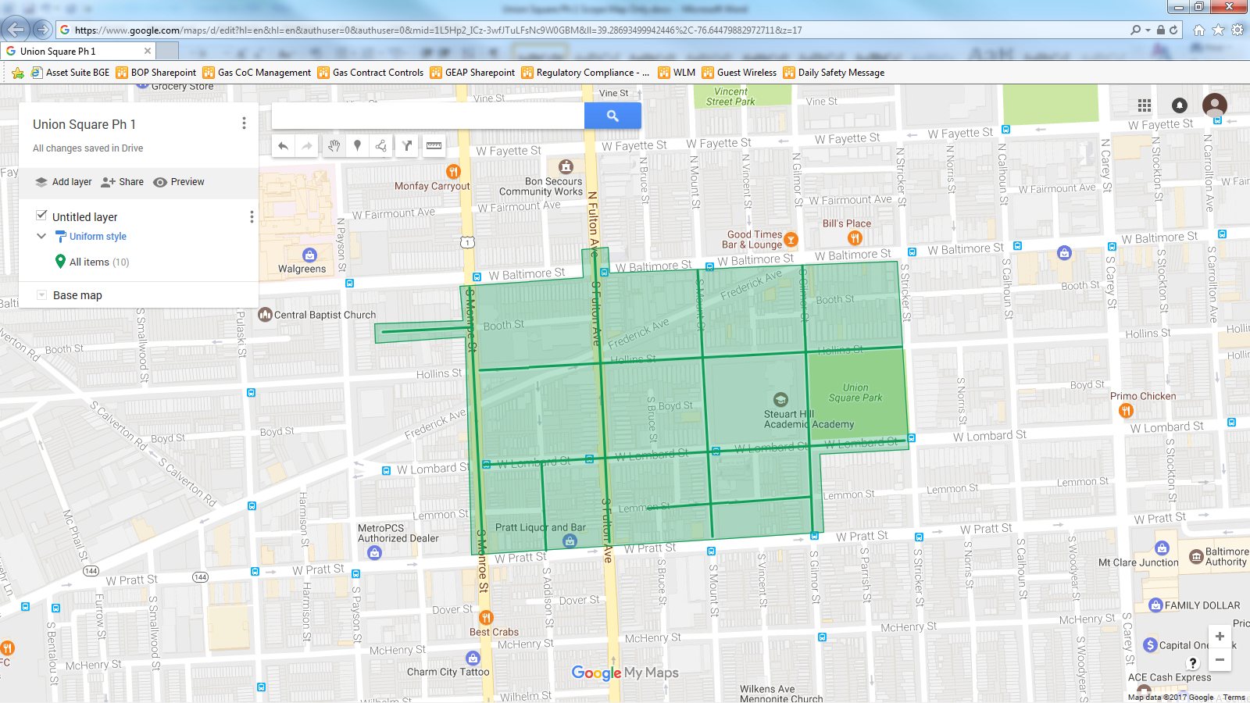

Figure 1: Union Square Operation Pipeline job shown shaded in green, with streets to be worked highlighted.