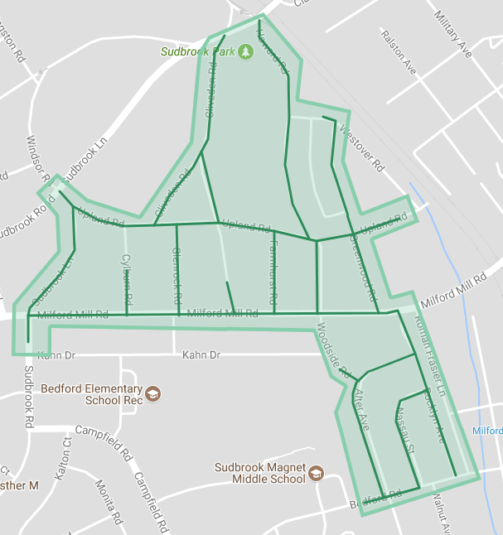

Figure 1: Sudbrook Park Ph 1 Operation Pipeline job shown shaded in green with streets to be worked highlighted.