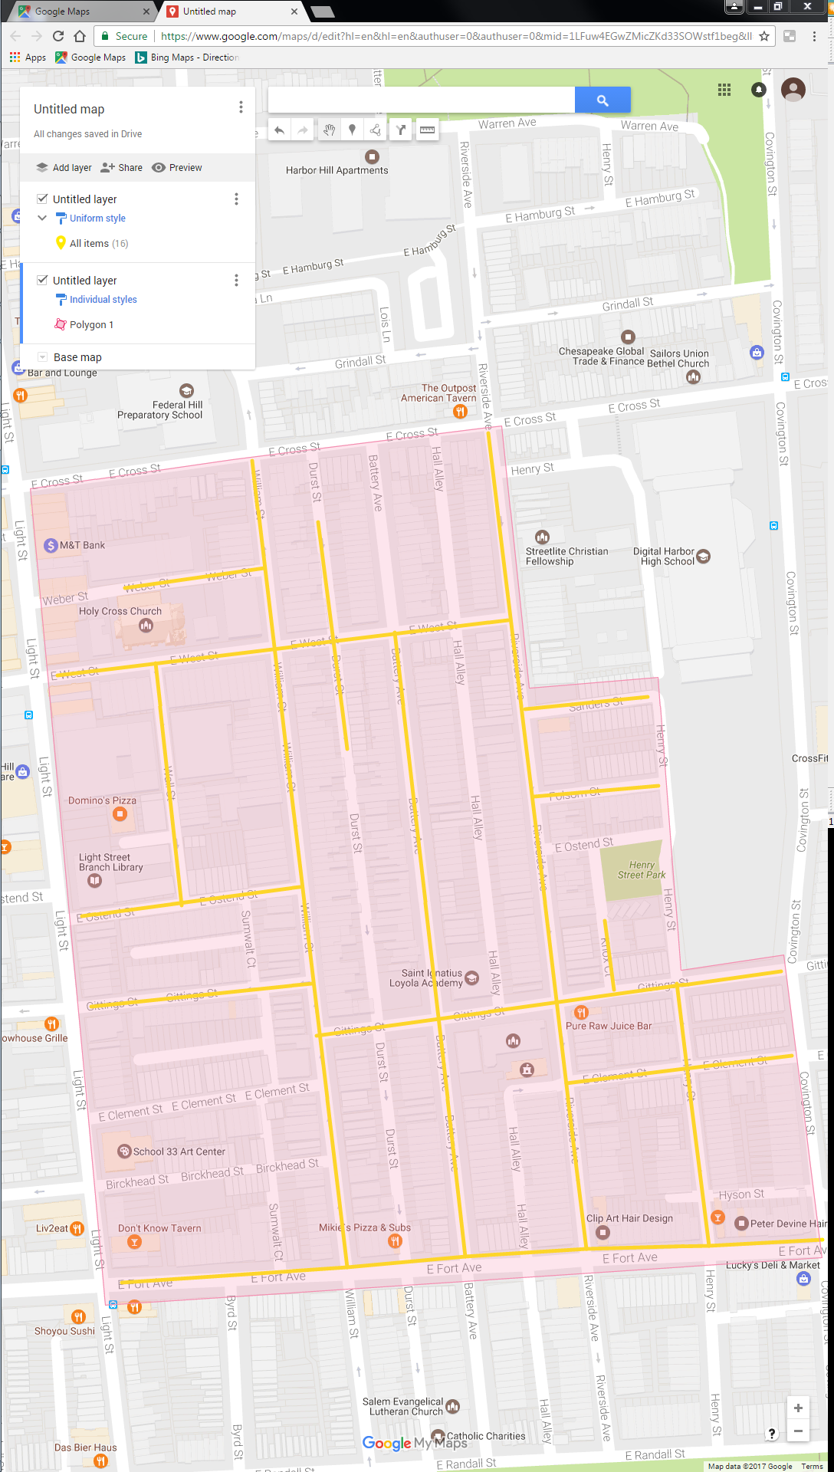

Figure 1: South Baltimore Ph 5 Operation Pipeline job shown shaded in pink, with streets to be worked highlighted.