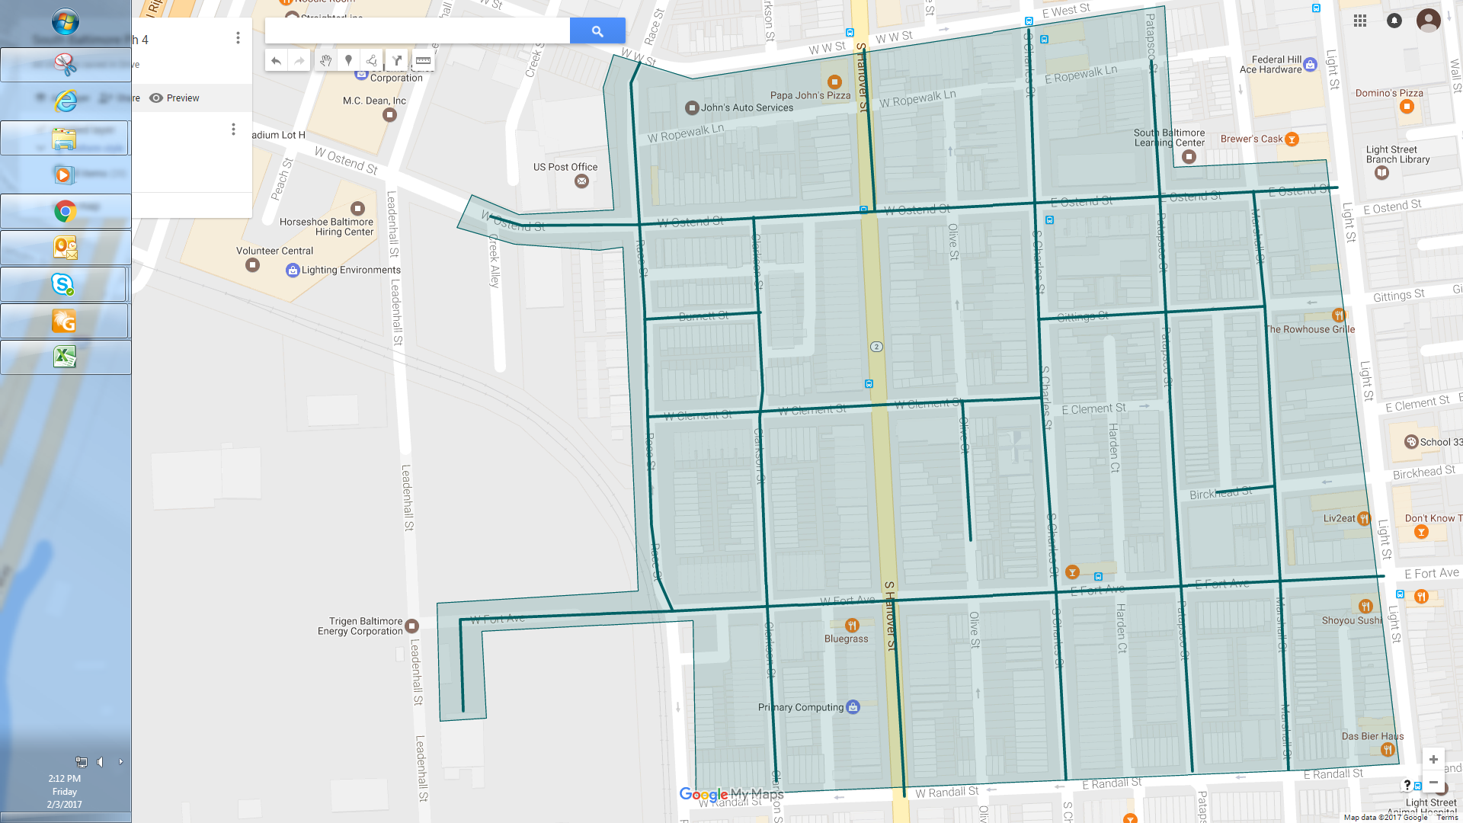

Figure 1: South Baltimore Ph 4 Operation Pipeline job shown shaded in green, with streets to be worked highlighted.