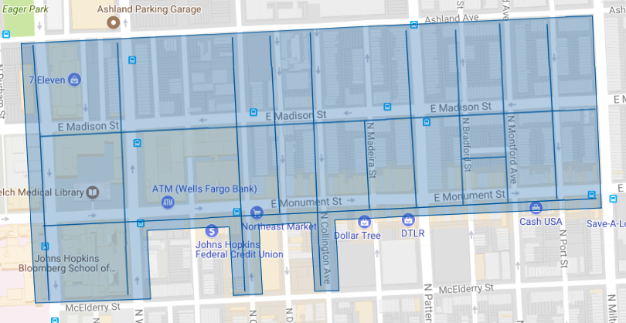

Figure 1: Middle East Phase 1 Operation Pipeline job shown shaded in blue with the streets to be worked highlighted.