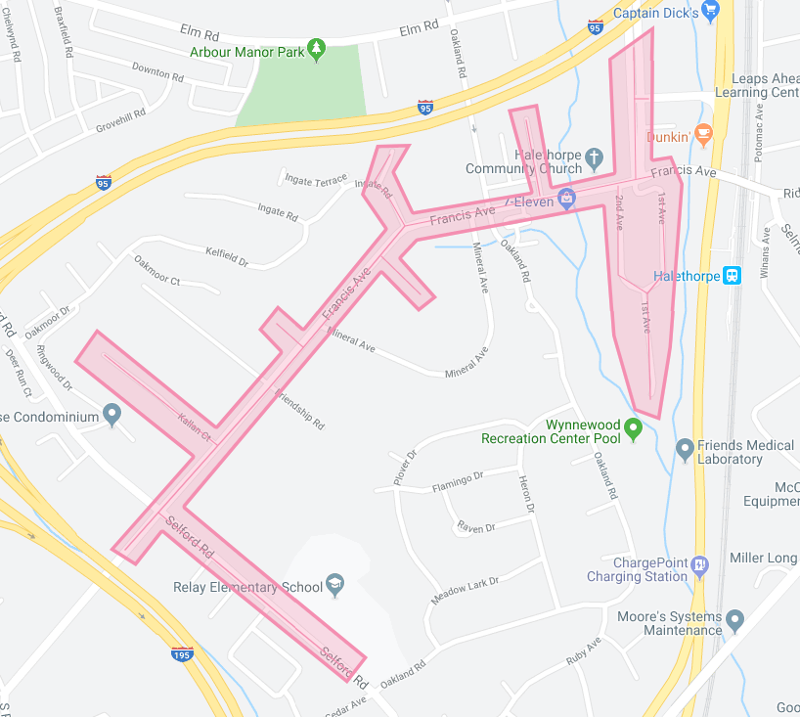

Figure 1: Relay Phase 2 Operation Pipeline job shown shaded in pink with the streets to be worked highlighted.