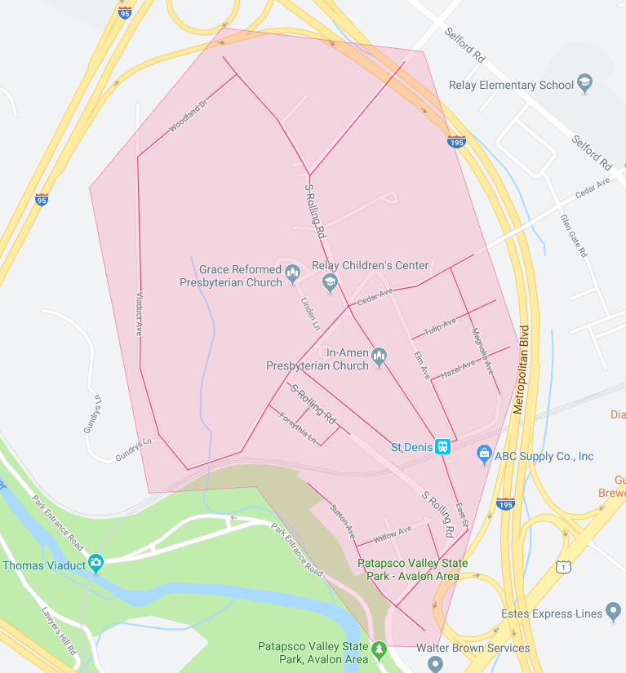

Figure 1: Relay Phase 1 Operation Pipeline job shown shaded in red with the streets to be worked highlighted.