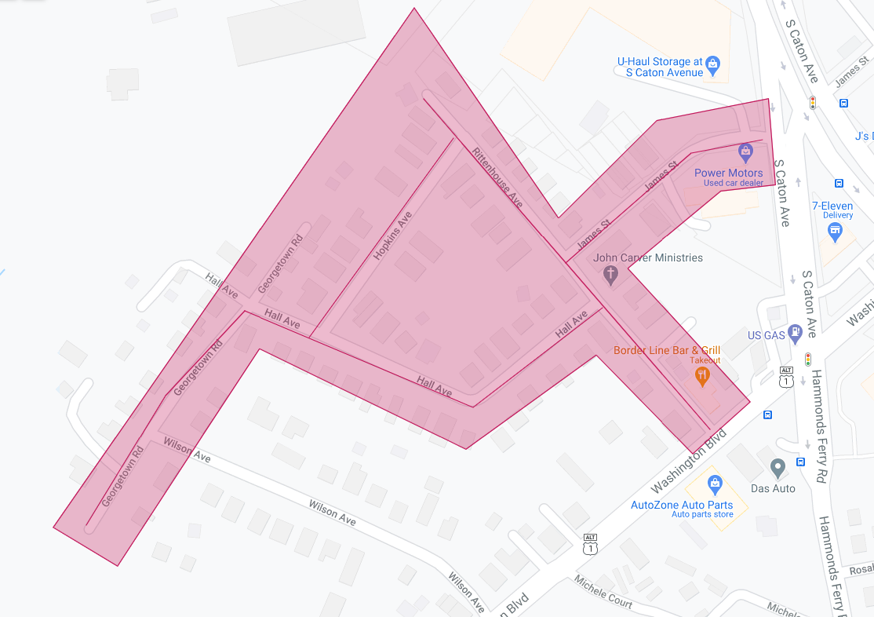

Figure 1: Morrell Park Phase 1 Operation Pipeline job shown shaded in red with the streets to be worked highlighted.