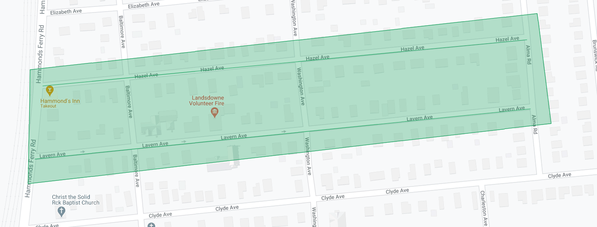

Figure 1: Lansdowne Phase 2 Operation Pipeline job shown shaded in green with the streets to be worked highlighted.