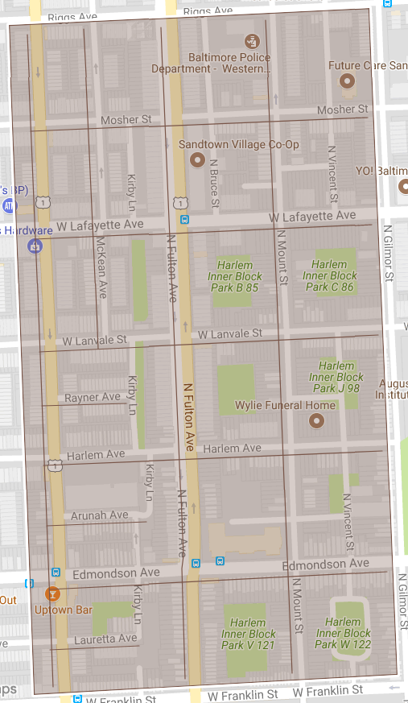

Figure 1: Harlem Park Phase 2 Operation Pipeline job shown shaded in brown with the streets to be worked highlighted.