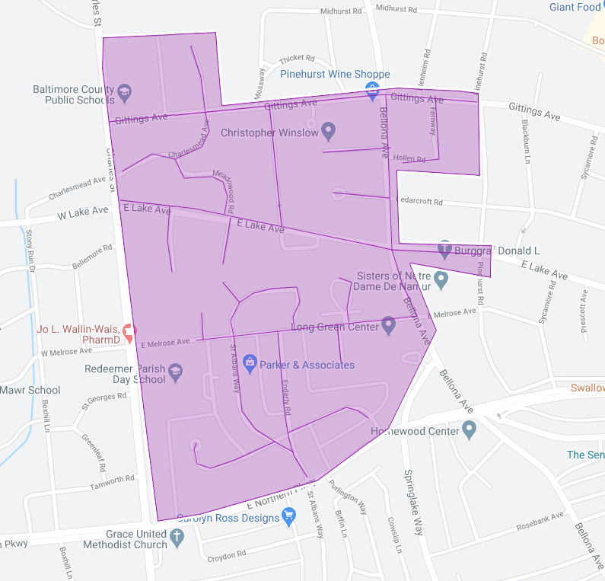

Figure 1: Bellona Gittings Operation Pipeline job shown shaded in purple with the streets to be worked highlighted.