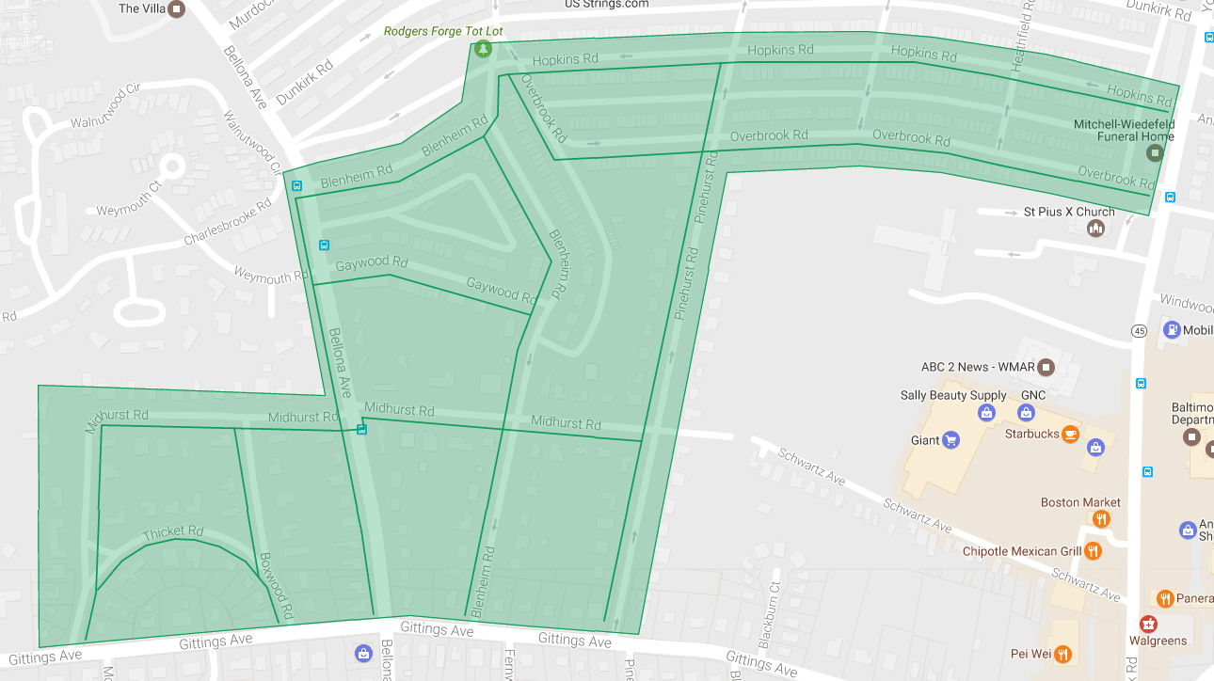

Figure 1: Rodgers Forge Ph 4 Operation Pipeline job shown shaded in green with the streets to be worked highlighted.