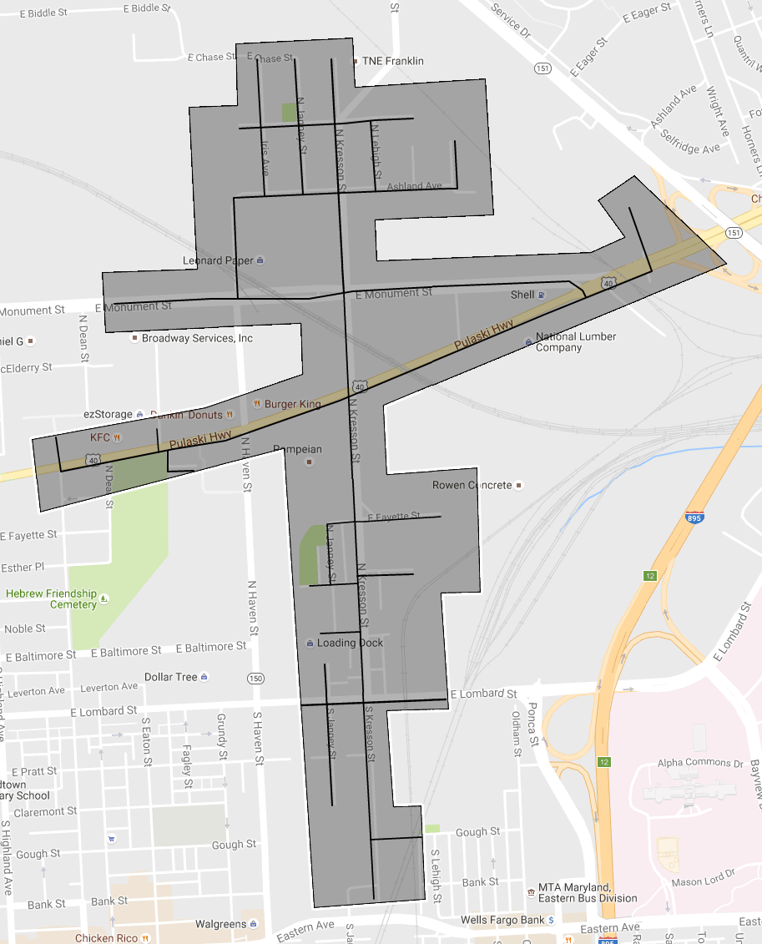

Figure 1: Kresson-Orangeville Operation Pipeline job shown shaded in gray with the streets to be worked highlighted.