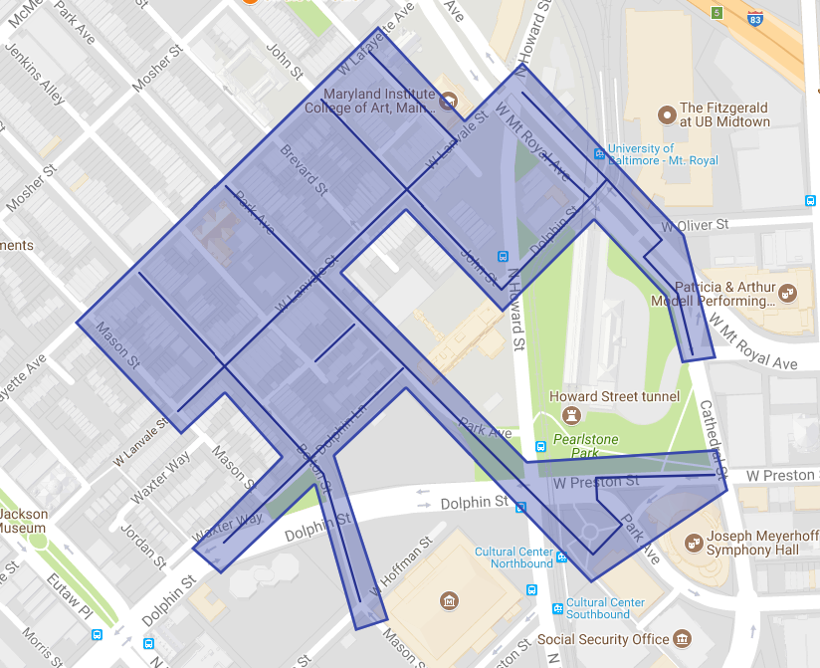

Figure 1: Bolton Hill Ph 1 Operation Pipeline job shown shaded in purple with streets to be worked highlighted.